**FOUR BIT RIPPLE CARRY ADDER**

LAB # 02



Spring 2025

CSE-308L

Digital System Design Lab

Submitted by: Naveed Ahmad

Registration No.: 22PWCSE2165

Class Section: B

Student Signature: ______________

Submitted to:

Engr. Shah Zada Fahim Jan

05 March 2025

Department of Computer Systems Engineering

University of Engineering and Technology, Peshawar

FOUR BIT RIPPLE CARRY ADDER

OBJECTIVES:

* Learn top down and bottom-up design methodologies
* Data flow level modeling
* Gate level modeling

Lab Tasks:

Implement a 4-bit ripple carry adder using:

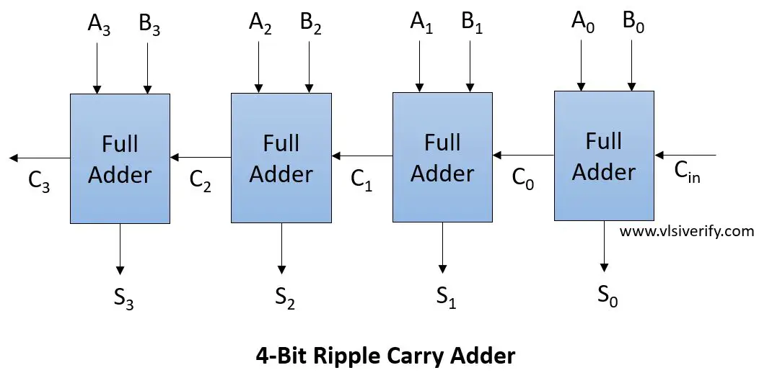

Task 1: Gate-level modeling?

Code

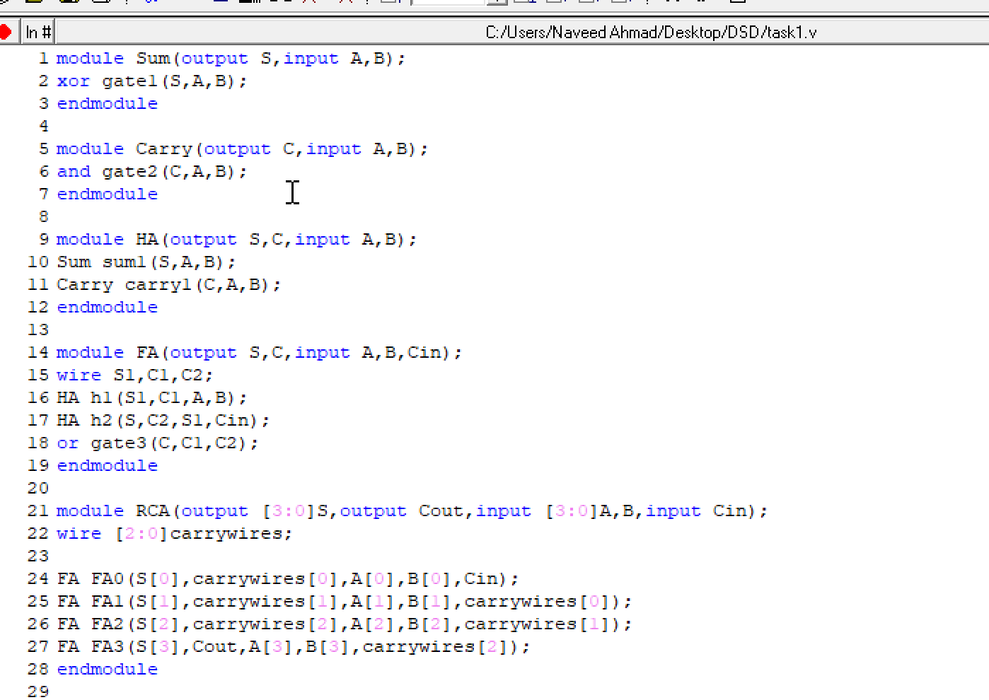



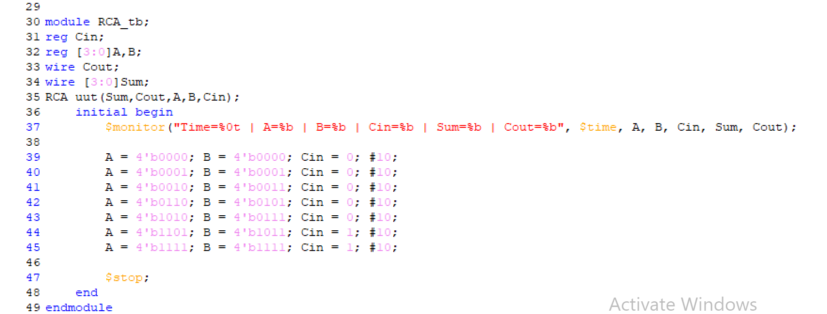

Truth table:

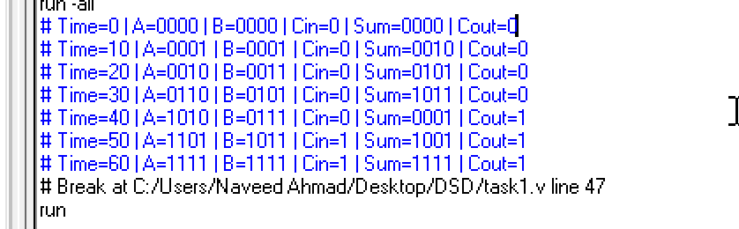

Output wave:

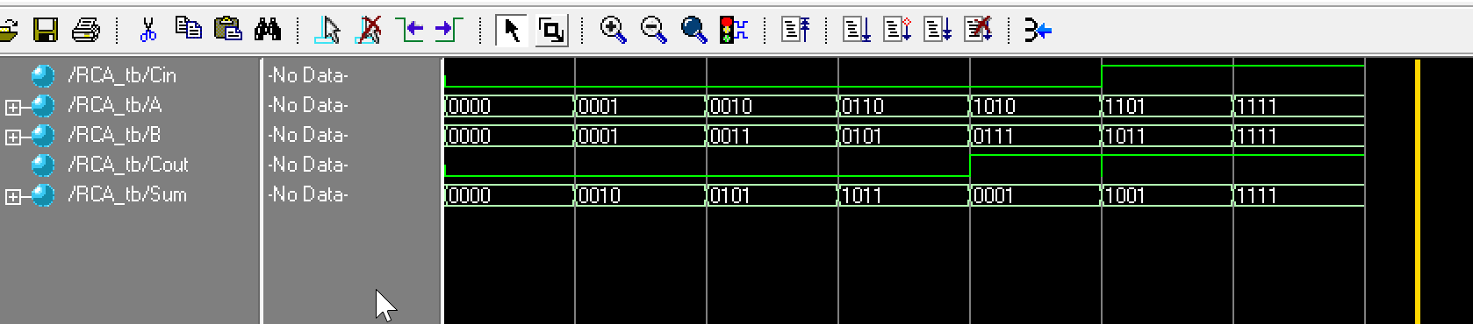

Task 2: Data-flow level modeling?

Code: 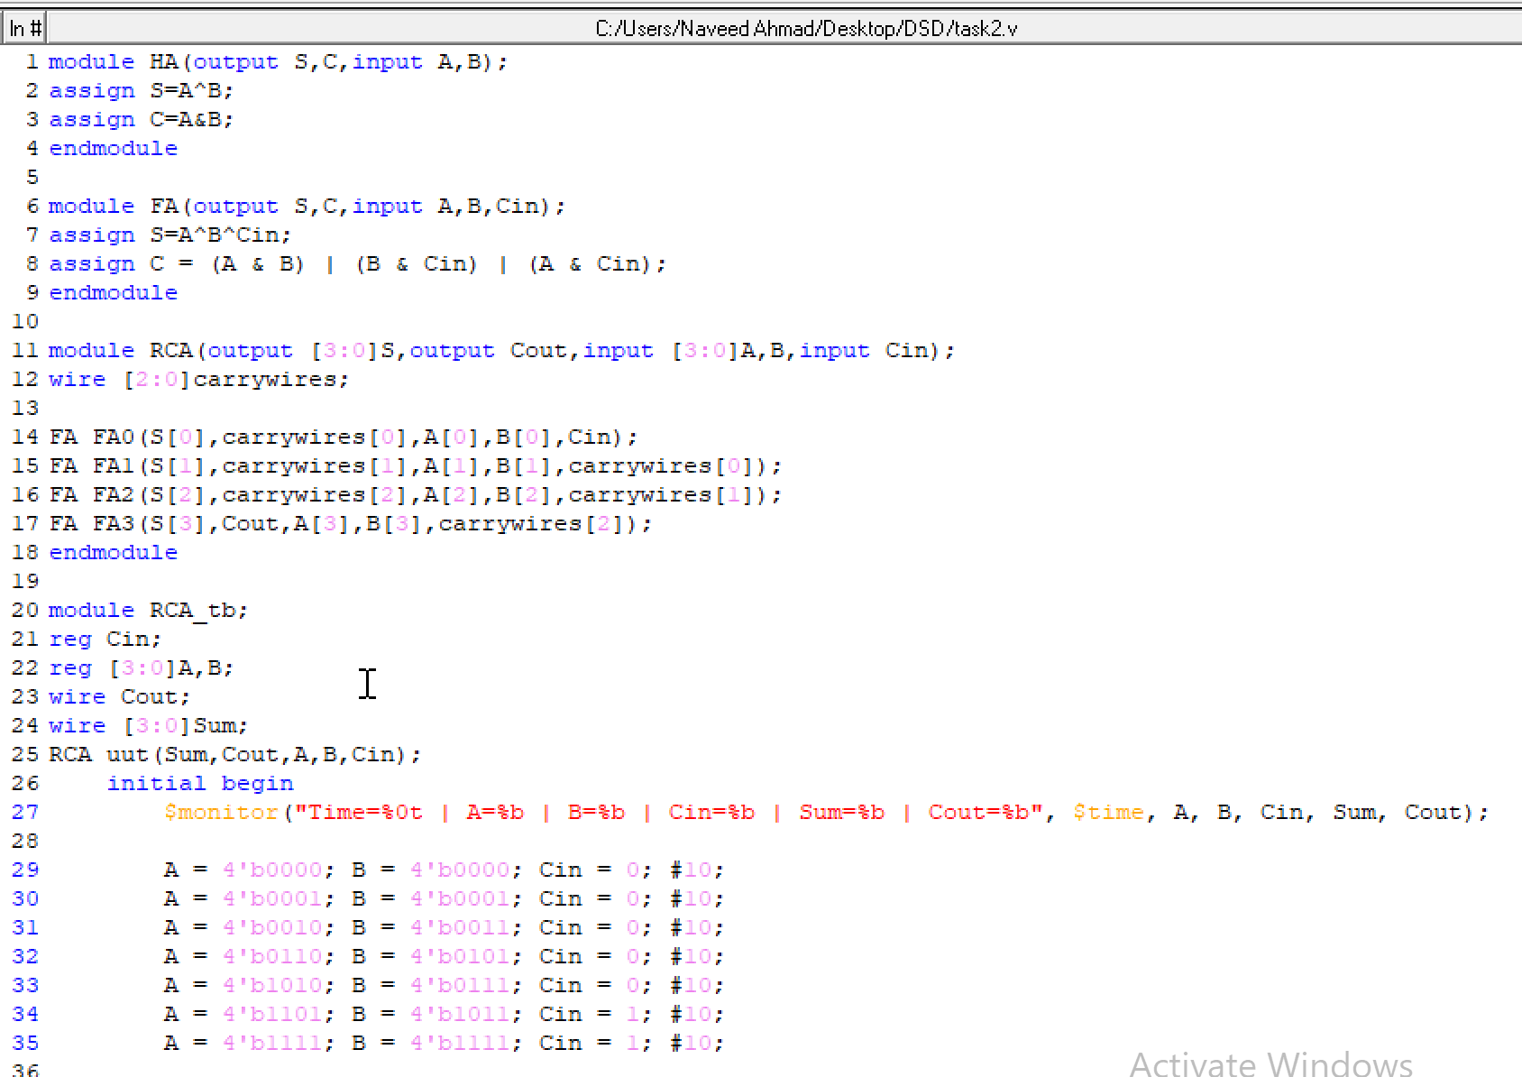



Truth table:

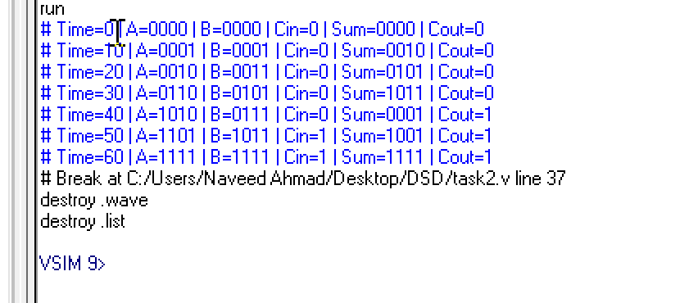

Wave:

